
CSA1102 OBJECT ORIENTED ANALYSIS AND DESIGN

CO2 AT3

Scenario-Based

Design UML diagrams to represent system requirements and architecture.

ASHMI.P.S
(192571004)
Smart Healthcare Management System
Scenario Description
A government hospital wants to develop a Smart Healthcare Management System to provide efficient and accessible healthcare services to patients. The existing manual system stores patient information separately in different departments such as registration, pharmacy, laboratory, and billing. This causes duplication of data, inconsistent medical records, and delays in patient treatment.
The proposed system provides a centralized healthcare platform where patients can register online, schedule appointments, access electronic health records, receive digital prescriptions, and make online payments. Doctors, nurses, pharmacists, and laboratory technicians can interact with the system to update patient information.
The system also includes emergency alert services, medicine inventory monitoring, and healthcare analytics dashboards to help hospital administrators improve decision-making and patient care.

1. Functional Requirements
Patient Registration
- Patients can create an account and register online.
- Patient details are stored in a centralized database.
- Existing patient information can be retrieved without duplication.
Appointment Management
- Patients can search doctors based on specialization.
- Patients can book, cancel, or reschedule appointments.
- Doctors can view their daily schedules.
Electronic Health Record (EHR)
- The system maintains complete patient medical history.
- Doctors can update diagnosis and treatment details.
- Laboratory technicians can upload test reports.
- Authorized users can access patient records.
Digital Prescription Management
- Doctors can generate electronic prescriptions.
- Patients can view and download prescriptions.
- Pharmacists can verify prescribed medicines.
Online Payment
- Patients can pay consultation and laboratory fees online.
- Payment transactions and receipts are maintained.
Emergency Alert System
- The system generates emergency notifications.
- Doctors and emergency staff receive immediate alerts.
Medicine Inventory Management
- Pharmacists can monitor medicine stock.
- The system provides low-stock and expiry alerts.
Healthcare Analytics
- Administrators can analyze patient data.
- Reports are generated for improving healthcare services.

2. Non-Functional Requirements
Performance
- The system should provide quick access to patient records and appointments.
Security
- Patient medical information should be protected.
- Role-based access should be provided for doctors, nurses, and pharmacists.
Reliability
- The system should be available 24/7.
- Regular data backup should be maintained.
Scalability
- The system should support increasing numbers of patients and healthcare workers.
Usability
- The application should be easy to use for patients and hospital staff.
Maintainability
- The system should support future modifications and updates.

3. Actors Involved
Actor | Responsibility
Patient | Register, book appointments, view records, make payments
Doctor | Diagnose patients, update records, prescribe medicines
Nurse | Monitor patient status and update care information
Pharmacist | Manage medicines and verify prescriptions
Laboratory Technician | Upload laboratory test results
Administrator | Manage users and analyze healthcare reports
Payment Gateway | Process online payments
Emergency Service | Receive emergency notifications

4. Main Classes
Patient Class
Attributes:
- Patient_ID
- Name
- Age
- Gender
- Contact_Number
Methods:
- Register()
- BookAppointment()
- ViewRecord()
- MakePayment()

Doctor Class
Attributes:
- Doctor_ID
- Doctor_Name
- Specialization
Methods:
- DiagnosePatient()
- UpdateMedicalRecord()
- GeneratePrescription()

Appointment Class
Attributes:
- Appointment_ID
- Date
- Time
- Status
Methods:
- ScheduleAppointment()
- CancelAppointment()

MedicalRecord Class
Attributes:
- Record_ID
- Diagnosis
- Treatment
- Medical_History
Methods:
- AddRecord()
- ViewRecord()

Prescription Class
Attributes:
- Prescription_ID
- Medicine_Name
- Dosage

Methods:
- CreatePrescription()
- ViewPrescription()

Pharmacy Class
Attributes:
- Medicine_ID
- Medicine_Name
- Quantity
Methods:
- CheckStock()
- UpdateInventory()

Payment Class
Attributes:
- Payment_ID
- Amount
- Payment_Status
Methods:
- ProcessPayment()
- GenerateReceipt()

5. Class Relationships
Patient and Appointment
- One patient can have multiple appointments.

Doctor and Appointment
- One doctor handles many appointments.
Patient and Medical Record
- Patient has medical records.
Doctor and Prescription
- Doctor creates prescriptions.
Prescription and Medicine
- One prescription contains multiple medicines.

UML Sequence Diagram: Patient Appointment and Digital Prescription
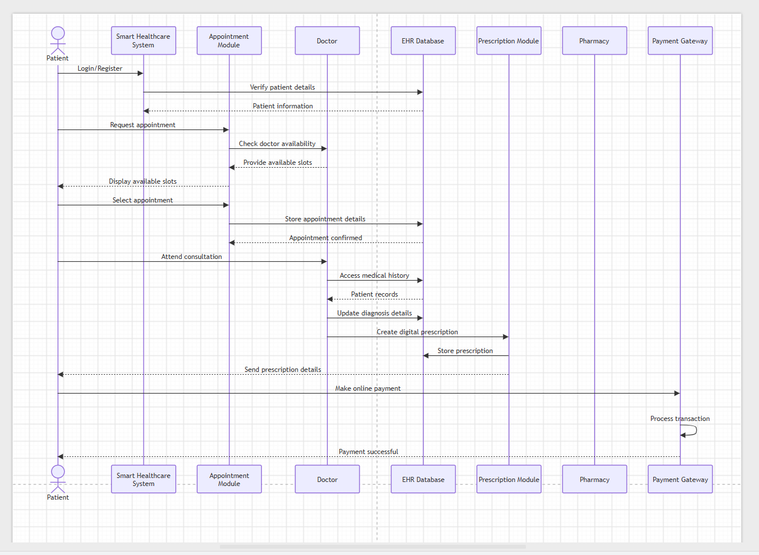
Conclusion
The Smart Healthcare Management System improves healthcare delivery by centralizing patient information, reducing data redundancy, and enabling faster communication between healthcare departments. Object-oriented concepts such as classes, inheritance, encapsulation, and modular design help create a scalable and maintainable system. The UML diagrams, especially the sequence diagram, clearly represent the interaction flow between patients, doctors, and healthcare services while supporting SDG 3: Good Health and Well-being.

